DRAFT (to be updated after discussion)

Report on results of the Oversight visit to the Karaganda region

7-11 September 2020

Purpose of the visit:
Performing the oversight function of the Country Coordinating Committee on work with international organizations on HIV and Tuberculosis (hereinafter – the CCM) by analyzing progress and gaps in the implementation of projects funded from the grant of the Global Fund to Fight AIDS, Tuberculosis and Malaria (hereinafter – the Global Fund).

Objectives:
- Analysis of the reports of the Global Fund grant regional subrecipients for 2019 and the first half 2020: assessment of challenges and achievements at the time of the visit.
- Analysis of the interventions implemented following the CCM oversight committee’s recommendations for regional subrecipients provided during previous visits.
- Meetings with the Head of the Regional Health Administration, the Global Fund grant regional subrecipients according to the meeting schedule (see below) and obtaining information on the progress of the Global Fund grant: assess the quality of coordination between PR, SR, clients and partners.
- Discussion of the results of the visit with the Principal Recipients of the Global Fund grant – the Kazakh Scientific Center of Dermatology and Infectious Diseases of the Ministry of Healthcare (hereinafter - KSCDID) and the National Scientific Center of Phthisiopulmonology of the Ministry of Healthcare (hereinafter – NSCP).
- Elaboration of recommendations to address problems related to the project implementation and disseminate best practices to subrecipients from other regions.
- Sharing the report with recommendations to all CCM members and other stakeholders and interested parties.

Introduction
During the visit, the CCM Oversight Committee reviewed:
1) Progress in the implementation of the previous recommendations of the Oversight Committee for the Global Fund grants sub-recipients in Karaganda region.
2) Progress and gaps in grant implementation in 2019 and 2020.
3) To ensure sustainability of the Global Fund grant (implementation of commitments at the local level).

Participants of the Oversight visit:
- Goliusov A.T. - UNAIDS Country Director, disease expert, Chair of the CCM Oversight Committee (online).
- Katrenova A.N. – Chief Expert of the Committee for Safety and the Quality of Goods and Services of the Ministry of Healthcare (online).
- Amanzholov N. – President of the ALE “Kazakhstan Union of People Living with HIV”, NGO/PLHIV representative.
- Sauranbayeva M. – TB prevention expert.

Brief overview
The population of the Karaganda region is 1,380,538 people.
HIV epidemiological situation. In the Karaganda region, 288 HIV cases were registered for 8 months 2020, the indicator per 100,000 population is 20.9 (for 8 months 2019, 291 cases were registered, the indicator was 21.1), there is a decrease by 3 HIV cases. For 8 months 2020, 1 HIV case was registered among children under the age of 14, for 8 months 2019 - 1 case. The number of “D” registered children is 25 people. For 8 months 2020, the number of AIDS patients amounts to 45 people (8 months 2019 - 47 people). For 8 months 2020, an increase in the HIV incidence is noted in 6 territories of the Karaganda region. The largest increase is in the following areas: Zhezkazgan city + 1 case, Balkhash city +5 cases, Satpayev city +4 cases, Saran city +8 cases, Oskarovsky district +9 cases, Abay region + 3 cases. In Osakarovskiy district, out of 10 cases 22.2% were identified as contact persons during the epidemiological investigation of sexual contact, 55.5% of cases were registered among persons examined by epidemiological indications. Transmission routes: for 8 months 2020, in the region as a whole, the share of the parenteral route of transmission is 31.25% (90 cases), which is 19.4% lower compared to 8 months 2019 - (38.8%) (113 cases). The sexual route of transmission is 62.8% (181 cases), which is 10.1% higher in comparison with the same period of 2019 (57.0%) (166 cases), of which 21 people were identified through contact with HIV-infected.
TB epidemiological situation. The TB incidence was 17.8 versus 23.6 per 100,000 population for the same period in 2019 (abs. 245 cases versus 326 cases). This indicator is lower than the republican level which is 37.0 per 100,000 population (-4.6). There is a decrease in the prevalence rate by 27.7%, from 31.1 to 22.5 per 100,000 population (abs. 310 versus 428 cases). This figure is lower than the republican level which is 26.3 per 100,000 population. Decrease in the proportion of destructive TB forms is noted - by 1.9% (from 30.9% to 29.0%). There is a decrease in the mortality rate by 33.3% from 2.7 to 1.8 per 100,000 population (an absolute decrease from 62 to 53 cases). This indicator is higher than the republican one - 0.8 per 100,000 population. An increase in the outpatient treatment coverage of newly diagnosed patients without bacterial excretion is by 12%, from 57.9 % in 6 months 2019 up to 66.4%.
The TB detection rate in PHC by microscopy was 5.3% in 6 months 2020. WHO standard is 5-10%.

The Global Fund grant recipients in the Karaganda region:
№ | Grant recipients: | HIV (sub-subrecipients funded as per the agreement with the Regional AIDS Center) | Tuberculosis | Migrants | Methadone | Total
1 | “Regional Center for Prevention and Control of AIDS” (Regional AIDS Center) | 1  (overall coordination)
2 | NGO “Umit” | 1  (Karagandy, Balkhash) | 1  (convicted) | 1 |  | 3
3 | NGO “Shapagat” | 1  (Karagandy, Temirtau) | 1  (Temirtau) |  |  | 2
4 | NGO “GALA” | 1  (Karagandy, Temirtau, Saran, Shakhtinsk) |  |  |  | 1
5 | NGO “Sau Urpak” | 1  (Karagandy, Temirtau, Shakhtinsk) |  |  |  | 1
6 | NGO “Doveriye” | 1  (Temirtau, Zhezkazgan) |  |  |  | 1
7 | Regional TB Dispensary |  | 2  (Temirtau, Karagandy) |  |  | 2
8 | Regional Center for Mental Health |  |  |  | 2 (Temirtau, Karagandy) | 2
 | Total: |  |  |  |  | 12

In total, 12 projects are being implemented in the region under the Global Fund grant.

In the region, the Regional Coordination Council for Health Protection was established under the Akim of the Karaganda region, chaired by the Regional Deputy Akim.
The issues of implementing measures to counter the spread of HIV/AIDS and TB within the State Program for Health Development were considered in 2018. There were no meetings in 2019 and 2020.
The participants of the oversight visit reviewed the implementation of Global Fund projects in Karaganda and Temirtau. Consultations with project staff and clients, review of documentation reveal that resources are being used in line with the terms of reference. The services delivered by the implementing organizations are in demand by the project clients.
A meeting was held with Deputy Head of the Karaganda Regional Health Administration and Head of the Regional Center for Mental Health. The participants discussed issues of resuming the functioning of the OST site in Temirtau (earlier, Methadone distribution was transferred to Karagandy due to restrictive measures as the Narcology Unit in Temirtau was converted into an infectious diseases department for COVID patients). It took almost 4 hours for program participants in Temirtau to get to OST site. As a result, some of the OST program participants lost their jobs. The decision was supported by representatives of the Karaganda Regional Health Administration and the Regional Center for Mental Health. Starting from September 14, 2020, Methadone will be dispensed in Temirtau for OST program participants in Temirtau.
Furthermore, the oversight visit participants noted the need to continue allocating funding for HIV/AIDS and TB prevention programs, expanding state orders for nongovernmental organizations supporting the HIV/AIDS and TB programs.

Sub-recipient – the Regional Center for Prevention and Control of AIDS (hereinafter – the Regional AIDS Center)
Since January 1, 2018, a new Global Fund project on the HIV component is being implemented in the Karaganda region for 2018-2020.
The main goal of the grant is to create a sustainable national HIV response in Kazakhstan by institutionalizing the social contracting system and to enhance access of vulnerable population groups and people living with HIV to prevention, care and support services. The country faces the following challenges: objective 1 - to develop and implement a social contracting mechanism through AIDS service NGOs to ensure the sustainable national HIV response. Objective 2 - to strengthen prevention activities among vulnerable population groups, to provide a range of care and support services for people living with HIV. The Global Fund grant is fully aligned with the key country directions and activities under the country's international commitments to achieve the 90-90-90 targets and the goal of ending the HIV epidemic by 2030.
One of the key priorities is the HIV prevention among vulnerable populations, which implies an increase in the coverage of vulnerable populations with prevention measures, increased access to services, NGO-based rapid testing of vulnerable populations, allocation of state social orders for NGOs, introduction of protocols "Test and treat", and also increasing the motivation and adherence of PLHIV to ART.
For reference: 3 regions were selected in the Republic of Kazakhstan for grant implementation in 2018-2020: Almaty, Astana and Karaganda region. The reasons for the selection of these regions include unfavorable epidemiological situation in vulnerable groups, as well as the availability of sustainable funding from the government budget.
The Regional AIDS Center is the Principal Sub-Recipient of the Global Fund grant in the Karaganda region (according to the funding request). It conducted a competition to select sub-sub-recipients for the implementation of Global Fund grants among PWID, SW, MSM and PLHIV. The competition was carried out based on the Regulation on establishment of Competition Commission for the procurement of NGO services to carry out activities aimed at HIV prevention among key populations (PWID, SW, MSM), care and support for PLHIV in 2018, which was developed in line with the Order of the Minister of Finance of the Republic of Kazakhstan dated December 11, 2015 No. 648.
The program covers human resources, office rent, campaigns, promotions, telephone communication costs, procurement of a computer and other office expenses. Human resources also include the positions of outreach workers, distributed among the following organizations:
№ | Name of organization: | Number of outreach workers, 2018 | Number of outreach workers, 2020
1. | Regional AIDS Center | - | 10
2 | NGO “Doveriye” | 35 | 28
 | NGO «Umit» | 35 | 28
3 | NGO «Sau Urpak» | 10 | 8
4 | NGO «GALA» | 6 | 12
5 | Public Charitable Fund «Shapagat» | 18 | 14
 | Total: | 104
The physical verification of fixed assets received from the Kazakh Scientific Center of Dermatology and Infectious Diseases of the Ministry of Healthcare of the Republic of Kazakhstan was carried out and, based on the results, no discrepancy was found between the accounting data and the actual availability.
The issue of funding the procurement of test kits for laboratory monitoring of ART effectiveness, testing for the immune status and viral load of PLHIV was resolved in June 2018. The Alere Pima Analyzer was purchased for the Temirtau branch of the Karaganda Regional AIDS Center. 20-25 tests per day are conducted in Temirtau, it is assumed that 500 tests per month for 1300 PLHIV will be covered. Analysis is conducted the same day.

PWID
According to the rapid situation assessment (quantitative), PWID (RSA PWID) in 2018 amounted to 15,100, and in 2020 - 12,300 PWID (changes were made after recalculation of the estimated number): Karaganda - 6400 (2018) and 4300 (2019), Balkhash - 1700 (2018), 1900 (2019), Temirtau - 4800 (2018) and 3800 (2019), Zhezkazgan - 2200 (2018) and 1900 (2019), including direct coverage with prevention programs is 8456 people (56% of RSA) - 2018, 9223 PWID (74.9%) - 2019 and systematic coverage - 6172 PWID (50.2%). The data was obtained using the individual client records database (BDUIK). Basically, PWID are covered with prevention work being carried out through outreach workers.

SW
The SW component has been supported from the GFATM since 2018. Prevention activities were carried out from the local budget.
In 2020, according to RSA, the number of SW amounted to 1900 (2018) in the Karaganda region (2018, 2019 - 1500), including direct coverage in 2019 - 1385 (92% and systematic coverage - 564 (37.6%). In 2019, Sentinel Surveillance was conducted among SW. The main coverage of SW is carried out with the help of a mobile Trust Point, through outreach workers and visitors of the Friendly Clinic. Condoms "Venus", manufactured in Malaysia, were procured for SW from the local budget.
Recommendation to the Regional AIDS Center: given that starting from 2021, the outreach work among sex workers will not be supported within the Global Fund grant, attention and consideration should be given to increasing the number of outreach workers among SW by raising funds from the government budget or other sources of funding.

MSM
In August 2017, an information letter was received from KSCDID with a new MSM calculation - 4900 people, the data was confirmed in 2019. 12 positions of outreach workers have been allocated to work with MSM, supported by the Global Fund grant through the NGO “GALA” (for more details, pls. see the NGO GALA section). Direct coverage of MSM is 35% (1,732 people) in 2018 and 709 (14.4%) in 2019, and systematic coverage is 6.5% (320 people) in 2018 and 80 (1.6%) in 2019. This indicator has significantly decreased compared to 2018 due to the lack of access to the database (BDUIK).
Reaching MSM is carried out through outreach workers, who started working on April 1, 2018. The Global Fund has procured special condoms and lubricants for MSM. In December 2019, funding was allocated from the government budget to procure condoms, which the Regional AIDS Center began to distribute from the second half of 2020, before that there were condoms purchased from the Global Fund funds.
Recommendation to the Regional AIDS Center: a comparative data analysis of MSM coverage in the Karaganda region should be carried out, as the reason for the low coverage of MSM in 2019 compared to 2018 remains unclear, despite the fact that the number of outreach workers in 2018-2019 was the same.

Interaction with outreach workers
At present, outreach workers are referring their clients to the Regional AIDS Center and to the Friendly Clinic for testing where the dermatovenerologist provides counselling. The training is carried out by the grant sub-sub-recipients themselves and, if needed, the staff of the Regional AIDS Center is involved. In 2019, one seminar was held for outreach workers of each NGO. Experts on SW and MSM engaged by the GF PIU also conducted training.

Trust Points services. In the region, 13 stationary and 2 mobile Trust Points have been opened and are currently functioning (in Temirtau 1 stationary Trust Point was reduced). In Karaganda there are 8 stationary and 1 mobile Trust Points, which is a need, given the great geographical remoteness of the city districts. In Temirtau 2 stationary and 1 mobile Trust Points, Balkhash -1, Dzhezkazgan -2 stationary Trust Points (of which 1 is located in Satpayev).
The Regional AIDS Center-based Trust Point has the following commodities available: syringes of 2 ml., 5 ml. and 10 ml., condoms, disinfectants, containers for collecting used syringes. There are no information and education materials.
Visitors of the Trust Point at the Regional AIDS Center can also receive psychosocial counseling and take an HIV test (regular or rapid). Staff costs and provision of Trust Points with commodities is carried out mainly from the local budget. The workload on 1 Trust Point is at least 250 and up to 300 clients, outreach workers bring or refer their clients too (60% of the prevention programs coverage indicator and 80% of testing coverage).
In 2019, 4,483 PWID received services in stationary and 360 PWID in mobile Trust Points (52.5% of the total PWID coverage), the remaining 48% of PWID are covered by outreach workers. In 2019, 36 PLHIV were identified through outreach workers and Trust Points.
Commodities procured from the local budget are transferred from the Regional AIDS Center to the NGO pursuant to the Order of the Karaganda Regional Health Administration No. 16/Ө dated 02.14.2020. When distributing commodities, a workshop was conducted on the dispensing mechanism, the distributing procedure and submitting reporting forms to the Regional AIDS Center. The reports are submitted monthly and compared with the Individual client record database. Problem: many PWID have no ID documents, problems with paperwork as they have no registration at the place of residence and residence permit.
Recommendations to the Regional AIDS Center: to consider the possibility of contactless distribution of commodities, in the case of the second "wave" of COVID – 19.

Antiretroviral therapy
As of 01.01.2020, 2,389 HIV-infected people received ART. For 6 months of 2020, a total of 271 people were engaged in ART in the region - 212 people started treatment for the first time, 62 resumed treatment, 20 people arrived with treatment from other regions, 23 people left. 2517 people continue treatment.
166 people were withdrawn from treatment: 23 people left for other regions and 125 people were withdrawn from treatment for various reasons:
- died - 43; refusal of treatment - 44; low adherence - 46; side effects - 1;
- severe clinical condition - 5.
Refusals of patients from ART for the period of 2019 decreased to 44 (25%) in 2019 (in 2017 - 5%). Patients motivate refusals due to frequent scheme changes, fatigue from prolonged use without interruptions, and psychological discomfort.
As of 01.07.2020, only 2517 people continue ART in the region, including 25 children. ART coverage is 80 out of 3140 in need, considering the expansion of indications for ART, coverage of patients without laboratory diagnostics of CD and VL.
Target indicator of the Memorandum for the Republic of Kazakhstan on ART coverage at the end of 2019 amounts to 67% of those who know their HIV status, this indicator is - 68%.
Adherence to ART in patients having received treatment for 12 months was 80% in 2019 (in 2018 - 77.5%).
There are problems with the formation of adherence:
- among patients who were enrolled in ART in a serious clinical condition due to the severe tolerability of ART drugs and treatment of opportunistic and non-infectious diseases; this problem has been solved by procuring new drugs that have fewer side effects, convenient amount and frequency of use.
- among patients with alcohol and drug addiction and persons without a permanent residence.
- among patients who are first enrolled in ART immediately upon detection, in the early HIV stages (stages 1-2), which is related to denial of the disease itself, low motivation of patients to treatment; patients continue to be enrolled from the moment of detection;
- the primary short-term side effects of drugs that disturb the well-being of patients.

In line with the requirements of the Ministry of Healthcare Order and the conditions of SK-Pharmacy, ARV drugs are dispensed for no more than 3 months. However, under quarantine conditions there is a need to dispense ARV for a longer period of up to 6 months, but under the supervision of an infectious disease doctor.
Some of the ARV drugs procured through UNICEF arrive in the country with a delay of 6 months or more leading to frequent changes in treatment regimen and, consequently, a high risk of developing resistance. Thus, at the end of the year there is a balance, which must be returned to SK-Pharmacy, respectively, the Regional AIDS Center is forced to refuse part of its order.
Recommendation to the Regional AIDS Center: a letter should be sent to the Kazakh Scientific Center of Dermatology and Infectious Diseases with a request to assist in resolving the issue, together with SK-Pharmacy, in maintaining a stock to provide ARV drugs at the beginning of next year, while the procurement for the new year is completed and the supply to the regions is carried out.
Friendly Clinic
At the time of the visit, 3 Friendly Clinics (hereinafter – FC) functioned in the region - in Karaganda, Temirtau and Dzhezkazgan, with a dermatovenerologist and a nurse available. The FC is equipped with a dry-heat box (currently not used as all instruments are disposable) and a gynecological chair. At present all instruments are disposable (diaper, gloves, mirror, spoon, cap, mask, shoe covers, mirror and Volkmann spoon). The services of the Friendly Clinic are in demand by vulnerable groups representatives, 4017 people visited FC in 2019. The main FC clients are PWID - 1392 people (34.6%), youth - 1374 (34.2%), SW - 746 (18.6%), MSM - 193 (4.8%), PLHIV - 312 (7.8%). In the friendly clinic, they try to conduct rapid testing and prescribe treatment. If there are fears that the patient will not come for a second appointment, the patient is given drugs for the full course of treatment. No drugs for FC were procured from the Global Fund.
In the Friendly Clinic, people can undergo STIs diagnosis and treatment, receive psychosocial counseling and take an HIV test (ELISA or rapid testing); in 2019, 3705 clients took rapid HIV testing. In 2019, 1815 people were diagnosed with STIs (1964 cases of STIs), of which 184 received syndromic treatment, and 1413 people - after laboratory diagnostics. If needed, the clients of the friendly clinic were referred for free diagnosis and treatment to the regional dermatovenous dispensary.
In the friendly clinic, 65433 condoms were distributed, including for SW – 53,258 pcs, PWID – 1,798 pcs, MSM-8,654 pcs, youth - 873, PLHIV - 850 pcs, as well as 111 pieces of information and education materials.
Since 2019, HIV ELISA tests have been carried out in FCs by presenting identity documents, which affected the attendance of FCs, for example, in the first half of 2020 - 631 SW visited FC, in 2019 - 668 SW, that is, 37 patients less. At the same time, visiting FC for other services also continues using identity codes registration.
During restrictive measures, the doctors of the friendly clinic consulted patients over the phone.
The Regional AIDS Center based lab diagnostics of STIs: chlamydia, HSV1, HSV2, trichomoniasis, ELISA, syphilis total antibodies, microreaction for syphilis.
The outreach workers of NGO have repeatedly noted that the cost of VH in the Regional AIDS Center amounts to KZT 2,800.
Recommendation to the Regional AIDS Center: an agreement should be concluded with the Regional General Hospital, which deals with the diagnosis and treatment of syphilis in accordance with the Ministry of Healthcare clinical protocols. The average need is 50 people per year.

The Regional Center of Phthisiopulmonology (RCP)
The Regional Center of Phthisiopulmonology (RCP) is currently participating in the implementation of the GFATM grant. The agreement for reimbursement of expenses No. 2019-10/9 dated January 03, 2019 between the RCP and the National Scientific Center of Phthisiopulmonology (NSCP) and an additional agreement were signed in the amount of KZT 1,302,346.15 to provide the following services:
1) Ensure the correct selection of patients for short-course and individual-tailored treatment regimen for TB in accordance with the practical recommendations on the use of short-term, standard and individual regimens for RR and M/XDR-TB treatment using new and repurposed TB drugs dated February 14, 2018 by the NSCP;
2) Organize and ensure regular clinical and lab monitoring, including management of adverse effects, for RR and M/XDR-TB patients on short-course and individual-tailored treatment regimen under the GF project;
3) Management of patients with TB/HIV concomitant pathology, with severe forms of M/XDR-TB, should be coordinated with the Central Medical Review Board of the NSCP;
4) Identify responsible persons for the preparation of financial and program reports;
5) Observe the terms of examination of RR and M/XDR-TB patients in accordance with the clinical and lab monitoring schedule in short-course and individual-tailored treatment regimens;
6) Include the following biochemical analyzes for reimbursement: glycosylated hemoglobin, creatinine, serum albumin, lipase, ionized electrolytes.
In 2019, in addition, KZT 12,180,234.00 were received for lab equipment and medicines.
Structure: as of December 31, 2019, there is 1 Regional TB dispensary in the region, with 3 subdivisions in Balkhash, Zhezkazg and Temirtau with a total bed capacity of 504 beds. In 2019, 74 beds were reduced in the RCP. Due to the reorganization of the Regional TB sanatorium for adults in Zhartas village, 50 sanatorium beds were added to the RCP (November 2019). These beds were converted into beds for rehabilitation treatment and medical rehabilitation by the Order of Karaganda Regional Health Administration "On the transfer of beds" No. 890-Ө dated 11/21/2019.
Distribution of 24-hour and day care beds by cities:

 | 24-hour beds | Day care beds
Karagandy | 310 | 25
RCP subdivision in Balkhash | 0 | 22
RCP subdivision in Zhezkazgan | 36 | 30
RCP subdivision in Temirtau | 108 | 10
Rehabilitation treatment and medical rehabilitation unit in Zhartas village | 50 | 0
Total in the region: | 504 | 87
 | 24-hour beds | Day care beds
Karagandy | 272 | 25
RCP subdivision in Balkhash | 0 | 22
RCP subdivision in Zhezkazgan | 36 | 30
RCP subdivision in Temirtau | 72 | 10
Rehabilitation treatment and medical rehabilitation unit in Zhartas village | 24 | 0
Total in the region: | 404 | 87
As of June 30, 2020, there is 1 Regional Center of Phthisiopulmonology in the region, with 3 subdivisions in Balkhash, Zhezkazgan and Temirtau with a total bed capacity of 404 beds. As per the Order of the Karaganda Regional Health Administration “On bed capacity optimization”, No. 915-Ө dated December 27, 2019 (the order comes into force on January 5, 2020), 100 beds have been reduced: 38 round-the-clock MDR-TB beds (Karaganda), 36 round-the-clock beds for MBT patients (Temirtau) and 26 rehabilitation beds (Zhartas village). Total number of 24-hour beds in the region - 404, total bed capacity of day care - 87.
TB care in city health facilities and in districts is carried out by the TB offices of the RCP, where counseling and dispensary observation of contingents are provided. District TB specialist and TB pediatrician monitor the X-ray records under the Integrated Medical Information System program as well as the implementation of tuberculin diagnostics.
The need was noted for the BARK VibroLUNG vibroacoustic device for the treatment of patients diagnosed with pulmonary fibrosis (patients who have suffered pneumonia of unknown etiology and have a high risk of developing pulmonary TB). Recommendation to PIU GF NSCP: solution to this issue should be considered.

Lab
Currently, GeneXpert (2 devices in Dzhezkazagan (through FIND) and in Karaganda), BACTEC and Hain-test are being used.
In 2020, 194 patients were diagnosed using Hain-test equipment, a total of 1393 tests were done, including 46 positive ones (3.3%).
In 2019, 5974 individuals were diagnosed, 6226 analyses were made, a total of 689 (11.1%) positive results.
The equipment received under the GFATM grant before 2019 is available and in working condition.
In 2014, reagents were obtained from the Global Fund for lab research using BACTEC and Hain-test. Hain and GeneXpert lab equipment were purchased from the Global Fund funds. The BACTEC analyzer was procured from the local budget. Balance of lab reagents was available at the time of the visit.
Recommendation to the RCP - 2018: 1) send a letter to the PIU GF with a request for procurement of three devices; Recommendation to the Regional Health Administration - 2018: consider procuring GeneXpert equipment for Karaganda (dispensary unit), Balkhash and Temirtau.
Recommendations of the previous visit were implemented. Four 4-module GeneXpert equipment were received on August 01, 2019. GeneXpert equipment was installed in the
recommended cities based in TB Dispensary.

Medicine Management
In 2019, 13 items of TB drugs were received from the Global Fund, in 2020, as of September 8, the following TB drugs were obtained: Bedaquiline 100 mg., Rifampicin + Isoniazid 150 + 75 mg and medicines (Vitamin B 50 mg / 50). The enrollment of GF project patients in 2019: for a short-course regimen - (15 patients) and an individual treatment regimen - (175 patients). In 2020, the enrollment of new patients under the Global Fund project was not planned, TB drugs were provided for patients continuing treatment since 2019 (individual-tailored treatment regimen - 12 patients). Since mid-2019, new and repurposed TB drugs for individual-tailored and short course treatment regimens have been procured from the republican budget (SK-Pharmacy). In total, 16 items of TB drugs were received to provide a complete treatment regimen, including children's dosages.

DOT at home
Directly observed therapy of patients at home (patronage) is carried out in Karaganda six times a week using the RCP vehicles (2 nurses visit 7 people each day). For the implementation of patronage, KZT 1,935,000 was allocated in 2019, and KZT 962,500 - for 6 months 2020. Selection criterion: the elderly people, patients with alcohol and drug addiction, people with disabilities, women with small children and patients in the postoperative period, as well as non-adherent patients (3). Also, video observed therapy has been introduced in the region (short-course, individual-tailored treatment, and category 4 (MDR TB), who cannot regularly visit the health facility). There were 45 smartphones and 250 7-slot pill organizers supplied from the Global Fund in 2020 and 50 in 2019.

Patient School
Patient education on the use of medicines, side effects and treatment regimens, nutrition during treatment, HIV and hepatitis is conducted by nurses from 4 Units in Dzhezkazgan and 1 Unit in Balkhash, there is an annual patient education plan in the "Patient School" and a schedule of trainings for nurses and patients for 2019-2020. In 2019, 62 nurses and 351 patients were trained, 351 patients were surveyed anonymously. For 6 months 2020, 68 nurses and 312 patients were trained, anonymous questionnaires were conducted for 312 patients. Display stands for the Patient School were designed.

Training of PHC staff
In 2019, 267 PHC specialists were trained. Trainings are carried out by: National Scientific Center of Phthisiopulmonology, Republican Center for Professional Development "Bilim", Republican Center for Professional Development "Sanat", Educational and Clinical Medical Center of Astana, Karaganda Medical University, Corporation for Innovative Development. For 6 months 2020, 72 PHC specialists were trained.

Social support
In 2019, social support was provided for 823 patients from the local budget through the Employment Coordination and Social Programs Department of the Karaganda region to increase patients’ adherence to treatment. Also, the Public Association "DAUA2050" (a new organization established by a phycologist of the Regional TB dispensary) provided social support distributing food and hygiene packages to TB outpatients in Balkhash, 20 patients monthly. In 4 districts of the region, hot meals are organized in day TB hospitals, the functioning of which was periodically suspended due to lockdown measures.

Monitoring and Evaluation visits
In the Regional Center of Phthisiopulmonology of the Karaganda region, a monitoring group of 6 specialists has been established, of which 3 are released specialists. The monitoring group is equipped with a separate office with a telephone, computers with Internet access, 1 car and 1 laptop. The RCP monitoring group conducts visits to the PHC and penitentiary facilities as per the schedule. In 2019, 64 visits were planned and carried out to each of the 18 regions and districts and health facilities of the region. Monitoring group reports are prepared in 3 copies and sent to the Karaganda Regional Health Administration and PHC. Reports follow a standard format.
For 8 months 2020, the Monitoring and Evaluation group specialists conducted 15 planned visits to PHC in Karaganda (polyclinic #1, JSC "Zhezkazgan Mining and Metallurgical Plant"), PHC in Balkhash (polyclinics #1,2), PHC in Temirtau (polyclinics #1,2, 3), PHC Shakhtinsk-2, Saran, Zhezkazgan, Satpayev, as well as district PHC (Osakarovsky, Nurinsky-3, Shetsky, Zhana-Arkinsky-2, Bukhar-Zhyrausky-4, Abaysky, Karkaralinsky, Ulytau district).
To enhance phthisiological vigilance in 2019 at the workplace, during monitoring visits M&E specialists conducted seminars among doctors of the general health network and trained more than 120 PHC doctors, including 70 nurses and lab technicians of the microscopic PHC laboratory.
The Monitoring and Evaluation reports track the recommendations issued during the previous visit. Recommendations are followed up repeatedly throughout the year. Unfulfilled recommendations are reviewed by the Regional Health Administration Permanent Commission which allows monitoring through the Situation Center.

Situation Center
In the Karaganda region, 9 Situation Centers have been opened to monitor the situation and improve the quality of work on the relationship with PHC on socially significant diseases. The Situation Centers are coordinated by the Regional Health Administration. For example, the Situation Center provides a monthly report to the MHIF (Mandatory Health Insurance Fund) and the Regional Health Administration on shortcomings in primary health care (pending fluorographic examinations, untimely examination of detainees). In case there is no examination of patients for TB in primary care, funding for primary health care is reduced. In 2020, the total number of those who did not undergo fluorographic examination for more than 12 months from the planned contingent was 2514 people, and over the same period in 2019, the number was 180 people, the coverage decreased by 13.4 times. Procurement of a portable fluorograph (digital low dose) that fits in a small vehicle could facilitate the issue resolution.
Recommendation to PIU GF: consider the possibility of solving this issue by procuring and organizing portable fluorographs.
As of 04.09.2020, the coverage of population groups at a high risk of the disease subject to compulsory fluorographic examination for TB was 84.7%.

Cooperation with NGO
The Memorandum of Cooperation with NGO "Umit" was signed on March 26, 2020. As for the implementation of this Memorandum, cooperation with NGO "Umit" should be enhanced, for example, paragraph 2.2.10 of the Memorandum of partnership "Posting information on the results of partnership with NGO “Umit" on the official website of the RCP”. At the time of the visit, the information has not yet been published. Recommendation to the RCP: the implementation issues should be reconsidered for each item of the Memorandum, and the results should be formalized with the appropriate completion forms.

The Regional Mental Health Center
The pilot project on opioid substitution therapy (hereinafter - OST) has been implemented at the Regional Mental Health Center of the Karaganda Region Health Administration since 2013 in compliance with the State license to engage in activities related to the circulation of narcotic drugs, psychotropic substances and precursors (No. 300036NsPvP) dated 02.06.2016 with a license validity period until 02.06.2021. The enrollment of patients in the OST program is carried out by a special commission. Before starting treatment, all patients sign an informed consent, and they are explained how to participate in the OST program.
The prescribed dose of Methadone is individual for each patient and varies from 10 mg to 135 mg. Urine testing for illegal drugs is carried out once a month and, if needed, upon joining the program and in case of doubt.
Since the start of the Methadone program in Temirtau, 156 patients have been registered cumulatively in the OST program. Of the 156 patients, 72 are HIV-infected, including 14 people receiving ART. 149 people dropped out of the program for the following reasons:
1) 27 (17.3%) patients completed the project as planned due to remission: remission for more than 5 years in 3 people (removed from the narcological register), remission for more than 3 years - in 10 patients, remission for more than 1 year in 11 patients and remission for less than 1 year in 3 patients;
2) 10 patients voluntarily completed the project ahead of schedule due to the lack of persistent motivation to completely abandon illegal drugs;
3) 7 patients were convicted of crimes committed before joining the project;
4) 7 patients left for other regions;
5) 27 patients dropped out of the project due to inpatient treatment;
6) 44 patients were excluded from the project for violation of the terms of the contract;
7) 4 patients left the country.
8) 11 patients left the program on their own will;
9) 12 patients died from concomitant diseases (4 people from cardiomyopathy, 1 from purulent pneumonia with acute pulmonary insufficiency, 1 from electrical injury, 1 from aneurysm of the femoral artery, 1 from poisoning with an unknown substance, 2 from HIV/AIDS, 1 from fatty liver disease, 1 from aneurysm of the ulnar artery).
Currently, new patients are not enrolled in the OST program in accordance with paragraph 1 of the meeting Minutes on the development of a unified position on the implementation of maintenance substitution therapy in Kazakhstan dated December 20, 2017 until a final decision on the prospects for its further use is made.
A meeting was held with former and current OST patients.
Recommendation to the Regional Mental Health Center and the Karaganda region Health Administration: Following the decision of the meeting, the issue of continuous implementation of the OST program should be considered providing Methadone for program participants in Karaganda and Temirtau without interruption despite restrictive measures; patients should not be transferred from Temirtau to Karaganda or vice versa.

Public Association «Umit»
The project is being implemented on the territory of the Karaganda region: Karagandy, Saran, Shakhtinsk, Balkhash. The project implementation period is from January 05, 2020 to December 31, 2020.
The goal of the project is a Comprehensive approach to medical and social rehabilitation of PWID within the Harm Reduction program. Project objectives:
1. Raise awareness of PWID in the formation of safe behavior skills with a view to the risks of HIV, HCV and HBV infections.
2. Provide information to PWID motivating for medical and social rehabilitation: drug addiction treatment and rehabilitation, OST program, overdose prevention and first aid, community capacity building.
3. Provide social support services for 9 components of the Harm Reduction program.

The project includes searching for and establishing contacts with PWID, exchange of disposable syringes, provision of condoms, alcohol wipes, IOM, informing/training PWID, engaging and accompanying PWID to trust points, conducting pre-test counseling, motivating and referring PWID to OST, preparing PWID to ART, chemoprophylaxis/TB treatment, Hepatitis, STIs, participation in Sentinel Surveillance and other studies, conducting trainings under the harm reduction program.
For now, the project has 25 outreach workers to work with PWID: 17 in Karaganda and 8 in Balkhash, who carry out two outings a week for 2 hours. The work experience of outreach workers ranges from 1 to 20 years. Coverage per 1 outreach worker per year is 70 PWID, at least 80% should be brought for testing.
For example, as per the reported data in August 2020, 55 (on average 11 clients per 1 outreach worker) new clients were reached and the systematic coverage was 1850 clients. 1,225 clients were tested for HIV (3-4 clients per 1 outreach worker). A total of 256,910 syringes (17 syringes per 1 PWID) and 69,289 condoms (5 condoms per 1 PWID) were distributed. Outreach workers distribute 5.0 ml and 2.0 ml syringes, as well as 10.0 ml syringes.
Training of outreach workers was carried out on a monthly basis. In July 2020, under the harm reduction program, the training was conducted by the Republican AIDS Center trainer, V. Malchikov. The coordinator of the NGO “Umit” conducted training on the Rules of COVID Prevention and Combustion Syndrome Prevention.
During the meeting with the outreach workers and PWID clients, a number of needs were highlighted: 5.0 and 10.0 ml syringes, access to OST for PWID from satellite cities, psychological support for OST clients, increasing payments for services taking into account inflation, and, if possible, increasing visits of mobile trust points in the most remote areas of the city, assistance in hospitalization of PWID for detoxification and referral to rehabilitation programs. It was also noted that the drug scene is represented by synthetic drugs (“speed”), heroin is supplied intermittently, therefore tropicamide and food poppy are also used. There is a need for consultation with a surgeon due to vein problems. There was a proposal from outreach workers to use video communication for contacts with the target group and consultation with specialists (mostly all have smartphones), as well as a request to inform the outreach workers about the departure of the mobile trust point the day before departure.
The number of PWID covered by prevention programs in the region (quarterly), data from NGO;
All organizations
PWID Karaganda+Balkhash | Q1 | Q2 | Q3 (July-August)
Number of new clients | 1394 | 315 | 141
Number of non-regular clients |  | 95 | 428
Systematic coverage |  | 1189 | 959
Direct coverage | 1394 | 1709 | 1850
Number of clients who received syringes | 1397 | 1599 | 1528
Number of syringes distributed | 58660 | 107550 | 90700
Number of clients who received condoms | 1394 | 1599 | 1528
Number of condoms distributed | 19305 | 30256 | 19728
Total number of clients tested for HIV | 566 | 482 | 213
Number of clients tested for HIV and received pre and post test counseling | 566 | 482 | 213
Number of clients who have been tested for HIV in the last 12 months and know their results | 566 | 1024 | 1225
Number of clients referred to Trust Point | 23
NGO "Umit" rents premises with an area of ​​52.5 sq. m. for KZT 130,000, which includes a warehouse and an office.
Supply contracts were concluded with LLP "Analit" (office rent), IE "Konstantinov" (maintenance), LLP "XTBM" (catering services), IE "Nuganova" (office supply), IE "Reventsov Fedor Dmitrievich" (KZT 54,000 – travel services).
As for VAT return, a letter was initiated as of September 7, 2020 to the State Revenue Department of the Karaganda region (according to the recommendations, once a year) with a request for VAT refund for 2019 in the amount of KZT 29,704. On April 2, 2020, KZT 29,704 was refunded.
Needs and suggestions from the staff of NGO "Umit": there is a need to conduct NGO-based rapid testing, which facilitates the coverage of clients with rapid testing; organize a mobile trust point on the basis of NGO as the project is being implemented not only in remote areas of Karaganda city, but also in Balkhash. Recommendation to NGO “Umit”, the Regional AIDS Center and PIU GF: jointly consider the possibility of mobilizing resources from different sources.
Recommendation to NGO "Umit" and the Regional AIDS Center: to establish a joint platform for NGOs working in HIV/AIDS and TB programs to discuss NGO-related program and financial issues and include them in the agenda of the meeting of the Public Council on Health in Karaganda region; NGO “Umit” is a member of this Council.

Public Charitable Foundation “Zhapagat”
Public Charitable Foundation "Shapagat" is implementing the project from the Global Fund grant for HIV component (Care and support of PLHIV).
The project is aimed at:
1. Building adherence -90%, undetectable viral load;
2. Motivation to start ART;
3. Recovery on ART;
4. Identification of PLHIV among sexual partners through NGO-based testing or by referral to the Regional AIDS Center.

Project staff, multidisciplinary team:
1. Peer consultants: from January to June 2020, there were 18 positions from the GF budget (10 - in Temirtau, based on “Shapagat” and 8 - in Karaganda, based on the Regional AIDS Center); from July to December 2020 - 10 positions under the GF budget (6 - in Temirtau, 4 - in Karaganda) and 4 positions from the Regional AIDS Center budget (in Temirtau and Karaganda – each per 2 positions).
2. Social workers: 4 positions from the GF budget (2 positions based on the Regional AIDS Center - full employment; 2 positions in Temirtau – full employment)
3. Psychologist: 2 positions from the GF budget: 1 psychologist (part-time employment) in Temirtau – “Shapagat”; 1 psychologist (part-time employment) in Karaganda – the Regional AIDS Center.
4. Database specialist - 1;
5. Accountant - 1;
6. Coordinator - 1.
A peer consultant performs the following functions: counseling on how to live with HIV, motivation and adherence to ART; referral/accompanying to dispensary monitoring; referral to a social worker for addressing health and social problems; referral to a self-help group (SHG) for PLHIV.
Since July, “Shapagat” continues working with a multi-disciplinary team (MDT) under the Global Fund grant, which includes psychologists - 2, social workers - 4 people, and peer consultants - 10 people. The main goal of this team is to involve patients in ART treatment, to search for patients with low adherence to ART treatment and who evade dispensary observation and return patients who have interrupted ART treatment. Searching for patients is carried out by MDT members through home visits, as well as counseling by phone to invite people to the Regional AIDS Center.
In 2020, “Shapagat” continued to work in such areas as the Patient School and the Mutual Aid Group with PLHIV. For 6 months 2020, 1,495 peer consultations, 22 "Self-help group" meetings, 24 online meetings covering 97 people were held.
An audio call with peer consultants showed that the patients they work with more often face problems with access to medical services due to the introduction of Mandatory Health Insurance. Not all PHC staff are aware of the issue of helping patients with socially significant diseases (for example, HIV, TB, etc.) through the Guaranteed volume of free medical care. PHC specialists explain this by the fact that PLHIV data is not in the Mandatory Health Insurance System and, accordingly, they require payment from personal expenses. Peer consultants do not agree with this, since according to the Code "On Public Health and the Health Care System" PHC should not demand payment. During the visit, the Polyclinic and the Abay Central Hospital were mentioned. PHC specialists should be covered with training and, if needed, update of the Mandatory Health Insurance System database should be considered. When meeting with the leadership of the Regional Health Administration, this issue was discussed, and it was promised that appropriate measures will be taken to retrain and instruct primary health care workers. "Shapagat" approached the NGO "AGEP" with a request to help resolve the issue. An official response from the Ministry of Health was obtained that the actions of Karaganda region medical workers are undue (Ref. No. 01-21/ZT-907-B dated September 09, 2020). Recommendation to “Shapagat”: this issue should be reviewed at a meeting of the multi-disciplinary team with the involvement of the Karaganda Regional AIDS Center specialists and followed up over time.
Recommendation to the Central Asian Association of PLHIV and the Kazakhstan Union of PLHIV: to provide technical assistance to “Shapagat” with the involvement of experts to train PHC staff on such issues as delivery of health services to PLHIV community, new areas of the Code on Public Health and the Healthcare System, as well as cooperation with NGOs.
The review of several minutes of the multidisciplinary team meetings showed that routine questions are discussed for the most. The agenda should be expanded, for example, finding solutions to the problems faced by peer consultants when working with PHC, etc.

Public Association «Sau Urpak»
NGO "Sau Urpak" has been working in the region with sex workers since 2001. From 2005 to 2014 it worked in the Global Fund project. A new project of NGO "Sau Urpak" under the Global Fund grant started in April 2018.
At the time of the visit, contracts were signed with Magnum Cash & Carry LLP, General Computer LLP, Taxi City to provide transport services, Almaty Kense LLP (three quotes were collected: Abdi LLP, Graphics LLP and LLP "Almaty Kense", the latter vendor delivers A4 paper at the lowest price).

From the approved budget, the monthly amount of KZT 18,000 is saved from the telephone services and KZT 10,000 from the office expenses. NGO "Sau Urpak" suggests using these funds to motivate clients. Recommendation to PIU GF KSCDID (2018): the proposal of NGO "Sau Urpak" should be considered, if possible, within the current rules and regulations. The Recommendation has been implemented.

Work with SW is carried out in Karaganda and Temirtau. At present, 8 outreach workers are working in the project. Until July 2020, there were 10 outreach workers: 8 in Karaganda and 2 in Temirtau. Coverage is 60 - 70 SW per one outreach worker. On average, each outreach worker should cover 5-6 SW in one visit and accompany at least 80% of the target group representatives to the Regional AIDS Center for HIV testing. During the visit, a meeting with 1 outreach worker was conducted. The work experience of outreach workers varies from 9 months to 8 years. Sex workers noted that there is a need for the Friendly Clinic services. Payment for outreach workers' services is KZT 47,200 tenge (KZT 42,500 thousand tenge – for the services, KZT 10,000 - travel allowance, KZT 1,500 - mobile communication costs). Compared to previous years, when SW worked on the streets, nowadays access to the group has become more difficult. Most of the work with sex workers is carried out:
1. By phone (internet sites, newspapers for ads);
2. Rented apartments;
3. Baths, saunas;
4. Roadside motels, hotels;
5. Massage salons;
6. Restaurants, cafes;

Access to the group is possible through the administrators of hotels and saunas. SW work through social networks and messengers. The payment amounts to KZT 15,000 – 20,000 per one contact. The Friendly Clinic has access to testing for HIV, Syphilis, Gonorrhea, Trichomonas. There is no syndromic treatment available.
During the conversation, the SW noted that the examination should be anonymous, as SW are afraid of information disclosure and breach of confidentiality.
During the period of coronavirus related lockdown, the delivery of services to SW was complicated due to restrictive measures, the number of clients decreased. Consultations were provided by phone, the Coordinator delivered condoms to outreach workers who then distributed to their clients at their points. It is not possible to work with sex workers on the phone (high mobile telephone costs) and when arranging night outreach trips (from 09:00 p.m. to 00:00 a.m.), outreach workers spend their own funds as the project does not support taxi costs, and at night public transport does not run and travel cards do not work.
The client records database is filled in by a database specialist. It is the responsibility of the specialist to enter the reports of outreach workers into the database and provide the Coordinator with outreach workers summary reports.
Outreach workers receive condoms at the NGO "Sau Urpak", which were dispensed by the Regional AIDS Center. Since the beginning of the year, 490,000 condoms have been received from the Regional AIDS Center. Condoms are distributed to clients based on their needs. One outreach worker receives 2000-3000 condoms per month. The number of condoms distributed per 1 sex worker varies from 60 to 100 condoms. Training of outreach workers is carried out once a quarter, and an online training was also conducted by the PIU GFATM. “Sau Urpak” employees were trained in setting and interpreting the result of a rapid HIV test (PEPFAR).

NGO «Doveriye»
NGO “Doveriye” has been working in the HIV/AIDS programs within the state social order since 2010.
Funds for work with PWID have been allocated to support 28 outreach workers who are expected to deliver prevention services among PWID. There are 21 outreach workers in Temirtau and 7 in Zhezkazgan. NGO “Doveriye” has obtained commodities for distribution that are stored in the warehouse. It was noted that not all storage conditions are followed, for example, there are no special pallets, that can result in changes of the commodities quality during long-term storage. Recommendation to NGO "Doveriye": this issue is to be resolved as soon as possible and the respective photos from the warehouse with installed pallets should be sent to the CCM Oversight Committee or to the PIU GF.
Clarification given by NGO “Doveriye”: The pallets are partially missing as a large number of commodities was received in the second half of 2020. To date, the recommendation has been accepted and the problem resolved. Commodities are stored on pallets.
Photo was received on 23 September 2020:
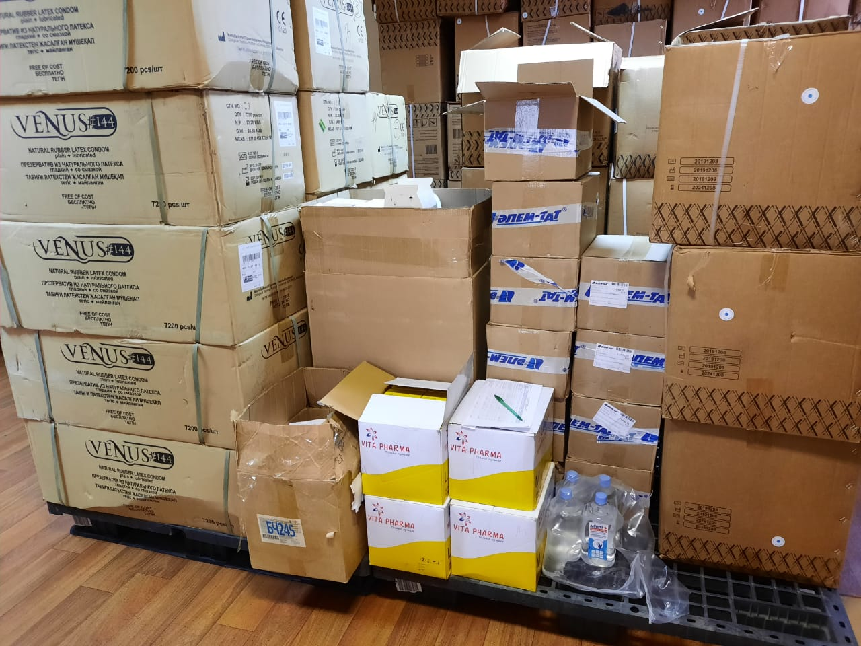 | 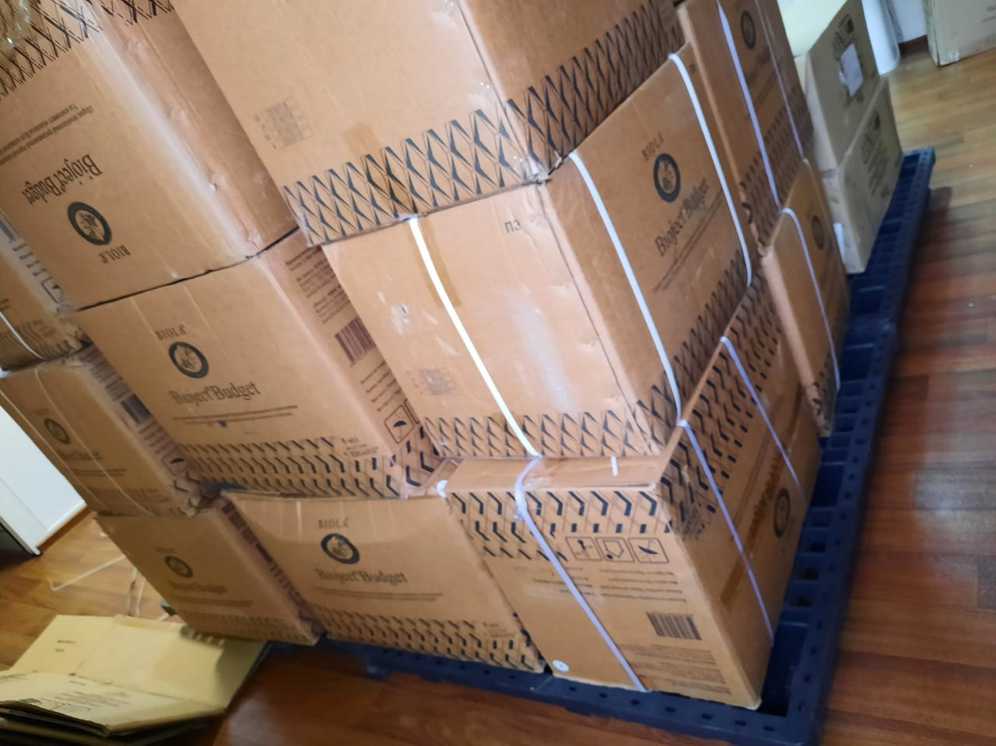

The project is being implemented in Temirtau and Zhezkazgan. The Agreement between NGO “Doveriye” and “Kazakh Pharmaceutical Company "MEDSERVICE” LLP was concluded to rent an office from 5 January to 31 December 2020. The monthly payment amounts to KZT 153,700. According to the outreach workers, the office location in Karaganda does not create any barriers to work and the warehouse at the office is convenient as well.
During the visit, meetings with 3 outreach workers for PWID in Temirtau were conducted. Until present there were no interruptions in work since all outreach workers were provided with certificates from the local executive body. Outreach workers receive KZT 47,200 (including KZT 10,000 travel allowances and KZT 1,500 for mobile communication). Questions were asked on satisfaction with services: all clients noted that the information sessions are conducted in an accessible language, the quality of syringes and condoms is satisfactory, syringes and condoms are provided in sufficient quantities. There were proposals to procure insulin needles.
Although the outreach workers and the project clients (PWID is the project target group) had to travel to Karaganda to take the drug (OST) during and after restrictive measures, NGO "Doveriye" did not send any letters or requests to the appropriate authorities and did not organize any meetings with the Regional Mental Health Center leadership to discuss ways to resolve this issue. Recommendation for NGO “Doveriye”: whenever possible, it is needed to analyze the problems faced by outreach workers and inform the Regional AIDS Center management or the multidisciplinary team of NGO “Shapagat” and ask for support in addressing issues or problems that create barriers to the program implementation among PWID.
Clarifications given by NGO “Doveriye”: Interaction has been established with OST participants and outreach workers. 3 outreach workers - Larissa Pankratova, Dulat Abylkanov, Yelena Krasovskaya are OST program members. The relationship is ongoing. Abylkanov Dulat (there were repeated violations, for which he was excluded from the program) and Krasovskaya Yelena were included in the OST program with the support of NGO “Doveriye”, and the head and specialists of the Regional AIDS Center. Several meetings were held with narcology representatives in Temirtau to discuss the issue of recovery and inclusion in the substitution therapy program.
NGO "Doveriye" asked about opening of an OST site in Temirtau. The reply was given that during the lockdown a provisional hospital was deployed in the narcology building in Temirtau and the OST participants were provided with the transport for Temirtau-Karaganda-Temirtau round trip. The remaining 4 people who participate in OST program, as of today, are not clients of the outreach workers of NGO “Doveriye”, as at present they are not using injecting drugs, and they are not provided with syringes or condoms.
Since July 2020, the Karaganda regional association "Doveriye" and the coordinator Nupinova A.M. have been assisting in the Public Fund "Aman-saulyk" project - "Support for OST program patients during the COVID-19 pandemic". Personal protective equipment, food kits and reimbursement of travel expenses are provided to the OST program participants in Karaganda and Temirtau (27 people). There is a constant communication with all the members of the OST site in Karaganda and Temirtau.
The project coordinator checks the data on the redirected and reached PWID with the Regional AIDS Center to monitor the outreach workers.
With regard to the allocation of funds and reporting procedures, the staff of NGO “Doveriye” highlighted certain concerns. For example, financing is now provided on a monthly basis, which creates additional work and unnecessary bank commission costs. It used to be quarterly and it was convenient for work. Proposals to return to the previous quarterly tranches and reporting were not heard and supported by the GF PIU.
It was also noted that although the Agreement with the Regional AIDS Center was signed in KZT and funding is received in KZT, for unknown reasons, financial reports on expenses are prepared in USD using the exchange rate. Furthermore, it was mentioned that due to the additional number of outreach workers, the stationary cost increased, but funding for this budget line was reduced. Recommendation for GF PIU and the Regional AIDS Center: this issue is to be considered and, if possible, to facilitate a solution or provide clarifications.
Clarifications of GF PIU: Transition to monthly funding does affect the bank commission of “Doveriye” since these are the costs of the PIU. In terms of control and monitoring of budget execution, monthly reporting allows to quickly get information and timely track the targeted use of grant funds. Taking into account the situation with exchange rate fluctuations, the PIU adheres to the policy of keeping funds in foreign currency and converting them as needed. Given that the amount of quarterly financing is significant, there will be a significant exchange rate difference (losses). If to analyze the work of an accountant for bank transactions, all payments are generally made at the end of the month. Since all transactions are similar, the accountant mostly enters them by copying the previous ones, which does not significantly affect the increase of workload. Previously, all supporting documents to the reports were checked by the accountants of the AIDS ​​Centers. The originals of the reports were filed in the AIDS ​​Centers. The PIU accountant checked the data on the consolidated financial reports and could analyze the supporting documentation only during the M&E visits. Since 2020, PIU has initiated a verification of all sub-recipient reports conducted by financial specialists, incl. of all supporting documentation (scanned copies are sent by e-mail), which, on the contrary, has expanded the opportunity to establish close cooperation with NGO accountants. Thus, monthly reporting provides up-to-date information for the donor, all comments on the preparation of financial reports or supporting documentation, if any, are eliminated promptly, without stretching it for quarterly terms. All financial reports and supporting documents are available in scanned form, filed by the PIU financial specialists, which allows remote verification of the correctness of filling out documents and the reliability of supporting accounting documents. All transfers are made in KZT. Reporting is requested in three forms: 1) Cash reconciliation report - reflects cash flow, control of balance and turnover for the reporting month, 2) Consolidated report - budget execution for the reporting month and with a cumulative total in the context of budget lines, 3) Detailed register - breakdown of expenses in the context of budget lines. In the reconciliation and detailed register there is a column for recalculating expenses as of the date of transactions in US dollars, including the amount of VAT paid. This recalculation is carried out by an automatic formula when loading the initial data of the official exchange rates, that is, physically accountants do not waste time on recalculation. The information in currency terms is used when preparing report to the donor (PUDR). For example, reporting on the previous forms reflected VAT on an accrual basis, while for the donor, the cash method was used, and the information was difficult to analyze. At the moment, when verifying budget execution, all three reports using new forms are convenient and effective for reconciliation.
If there is a need to increase expenses (for instance, for stationery), sub-sub-recipients can send a formal request to revise the budget based on the savings, if any, according to the financial reports.
This year, commodities were obtained two times: 1) 28 February 2020 – syringes 5 ml. 122,400 2 ml. - 121,500; condoms – 136,800; 2) 5 August 2020 – syringes 5 ml. 105,000, 2 ml. – 121,000, 10 ml – 15,000. Condoms – 13,200.
On 4 May 2020 the following items were received: masks – 2,376, gloves – 3,168, disinfectant – 45 l.
On 10 June 2020: respirators – 198.
On 5 August 2020: masks – 2,496, respirators – 312, gloves – 4,992, disinfectant – 18 l, pocket disinfectants – 20.
Additionally, a disinfecting mat, a lamp and a non-contact thermometer were received.

Public Association «Gays and Lesbians Alliance - GALA»

Public Association «Gays and Lesbians Alliance - GALA» is implementing the Global Fund project to carry out prevention activities in the MSM community.
In total, there are 12 outreach workers who work in different MSM locations. The locations of the MSM group are the following: “Pleshka”, Park in Karaganda, Maykuduk microdistrict in Temirtau, Abay, Shakhtinsk, Topar urban village, Saran, Aktas village, Sortirovka microdistrict, ‘’Luxor” gay club, social networks (VK, Instagram), messengers (Telegram, What’s app), dating apps for MSM (Greender, Hornet), inner circle, apartments. Private parties have become popular during lockdown (cottages are rented).
Every outreach worker who has been working since 2020 (new outreach workers) has to cover 75 MSM monthly and 80% of the coverage should be referred to the Regional AIDS Center or to “Amanbol” project for HIV testing (16 people in a quarter according to the agreement). The outreach workers who started working until 2020 should reach 100 MSM and send 80% of the coverage for testing to the Regional AIDS Center or “Amanbol” project. NGO receives condoms from the Regional AIDS Center, from the local budget. Condoms from the Global Fund were received in August (23,700) and in September (25,200). Meetings with 6 outreach workers and 11 clients have been held. Work experience of the outreach workers varies from 8 months to 15 years.
The outreach workers refer their clients to the Regional AIDS Centers using vouchers. The oral HIV testing is conducted at the NGO by trained staff (A. Saulina and S. Panina). There is an opportunity to conduct oral self-testing within the “Amanbol” project. In 2019, 4 outreach workers participated in the Summer Legal Camp held in Almaty. The same year, 6 outreach workers of NGO “GALA” took part in the training organized by the Global Fund for outreach workers working with SW. In 2020, the GF has conducted an online training for all outreach workers. There were no information and education materials provided in 2020.
Many MSM are being referred to the Friendly Clinic, but the opening hours of the Friendly Clinic is the same as the work schedule of MSM, as a result, not all MSM can receive the services at a time convenient for them. One of key concerns are self-stigma and stigma within the group. MSM do not want to get tested as they are afraid of publicity. It is also more of a self-stigma problem. Sampling for free PCR for STIs and HIV testing are carried out in the Friendly Clinic.
According to the outreach workers, the number of MSM in the Karaganda region is overestimated, as per the rapid situation assessment – 4,900, data for the last 2 years has not been updated. According to the assessment of the MSM community, the estimated number of MSM is maximum 3,000 including newcomers (consistent with the Kazakh Scientific Center of Dermatology and Infectious Diseases data). The increase in new cases is low, since many group members migrate to larger cities (Almaty, Nur-Sultan). Sentinel Surveillance among the MSM group was held in the fall 2019, outreach workers took an active part in it.
Social networks are used for interaction of MSM projects and outreach workers with the MSM community.
Problems pointed out by GALA’s accountant: since April 2020, financial reports are provided on a monthly basis, previously the report was provided on a quarterly basis. For NGOs, monthly reporting is inconvenient, since it is difficult to plan expenses (procurement of stationery), as well as to transfer expenses from one budget item to another, as the time period for obtaining approval from the GF PIU is longer, it is rather difficult to get approval in a month. As a result, at the end of the year, there will be savings formed due to the lockdown in the country and the inability to hold events offline. Recommendation for PIU GF and the Regional AIDS Center: this issue is to be considered and, if possible, to facilitate a solution or provide clarifications.
During the visit, meetings were held with community representatives and NGOs, including the MSM community and NGO that work with this group - the NGO "GALA" - to find out how the GFATM project works in the Karaganda region, including NGO "GALA", and clarify the circumstances mentioned during an online meeting with the MSM community regarding an article posted on social networks. A separate meeting took place with one representative of the MSM community, who independently came to the meeting at the Temirtau AIDS Center, when the Oversight Committee members met with representatives of several communities. He approached one of the Oversight Committee members, introduced himself and expressed a desire to discuss several issues. Further, the meeting took place behind closed doors in another office. During the meeting, access to services and prevention work among MSM group were discussed, carried out by NGOs and health facilities including the Regional AIDS Center. He expressed his opinion regarding work of the NGO "GALA" and provided some information noted in the Kok.team publication and told how he obtained this information, as well as some details. Conversations with the rest of the MSM group were conducted over the phone, almost all of them raised the issue of publication and expressed their opinion. The meetings were organized both with outreach workers and clients of the NGO "GALA", and with MSM community representatives not working for NGO, but activists and volunteers. During the communication with the volunteer activists, a positive assessment of GALA’s performance was received, and several proposals were made regarding working with the MSM community in the region (the need to support work in Temirtau, etc.). Also, several activists asked to be included in the group of a platform for the MSM community, and provided their contact details, which were passed on to the UNAIDS representative as a coordinator of platform related work. Permission to share contact details was obtained through correspondence with activists and MSM community representatives. It was important to get an independent opinion from MSM community representatives of the Karaganda region.
Clarifications of GF PIU: Monthly reporting and monthly funding do not interfere with effective cost planning. To obtain funding, an application form was developed, according to which the sub-sub-recipient can indicate its planned expenses in line with the approved budget for the reporting month, taking into account those expenses that require prepayment for subsequent periods (office rent), procurement of stationery - many suppliers provide free delivery upon reaching a certain amount threshold, it is possible to procure goods on a quarterly basis. Such requests are approved and funded by PIU. Any budget revision or use of savings is possible only after getting approval of the PIU, it is much more efficient to do this monthly than on a quarterly basis. So, to decide on the use of savings, the sub-sub-recipient must submit a financial report, which, on the contrary, will lead to a delay in the consideration of requests. Monthly reporting increases the workload primarily for PIU finance specialists, as they enter data into the database for each NGO separately.

Furthermore, during the visit, issues have been discussed mentioned in the “Kok.team” article (post on the Kok.team website).
1) Expired lubricants: at the time of the visit to the GALA office, there were 33 lubricants with an expiration date until May 2020 (photo available), which were not distributed for the program and will not be used in work. The outreach workers noted that, according to the assumptions of the GALA employees, the author of the article is an outreach worker who resigned from February 1, 2020, as he was unable to restore the lost tests of the “Amanbol” project. For now, he has got a new job. These lubricants are referenced in the article.

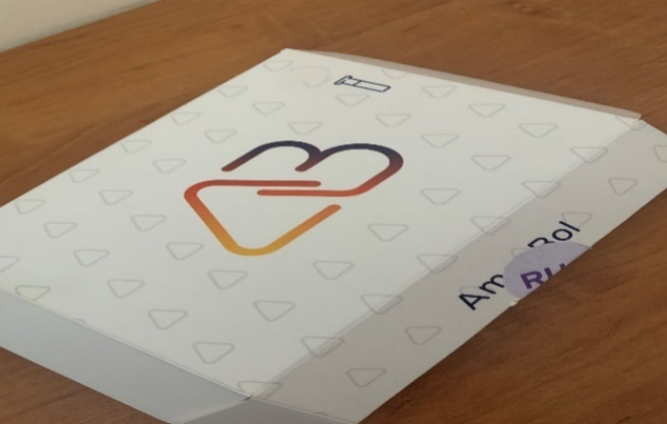 | 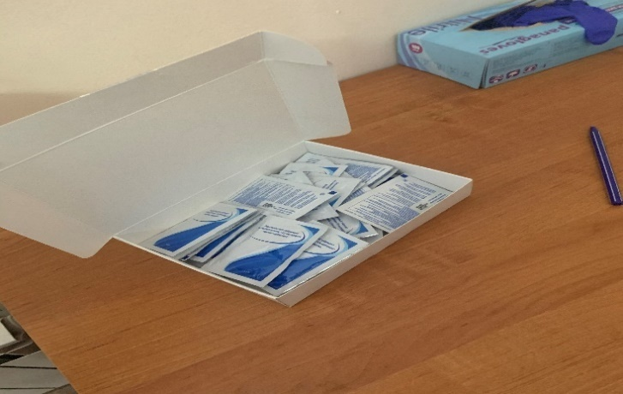
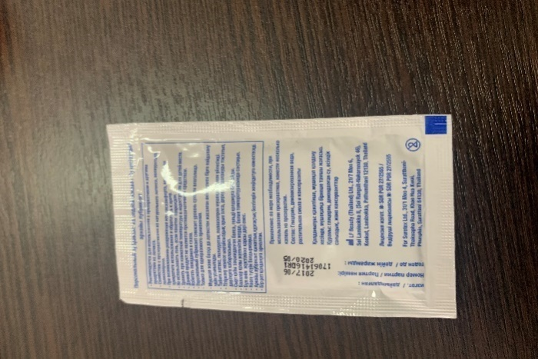

- In November 2019, NGO "GALA" was preparing for the campaign taking out condoms and lubricants from the office in one large box for distribution during the campaign (120 kits) in a nightclub. A total of 56 kits were distributed to 56 people, although it was planned to reach 120 people, there were few people in the club that day. The rest (64 kits) was brought back to the office. As the campaign took place on November 30, 2019, all remaining condoms were transferred to December 2019. Referring to the fact that the outreach workers should distribute the last month balance (left after the campaign) in December, the project manager A. Saulina asked the outreach workers in the chat to distribute the leftovers - 64 kits along with the plan for December 2019. According to the Head of the organization, the chat message was about this.
- The head of NGO “GALA” confirms that she took empty boxes of condoms and lubricants for household use. For transportation purposes, she asked a friend to help her free of charge.
- In April 2019, a letter dated 23 April 2019 was sent to the GF PIU with a request to allow the outreach workers to distribute 1 condom and 2 lubricants (note of the outreach worker: to lubricate your partner and yourself). The issue of redistributing short-life lubricants to other regions was not discussed. A response was received via e-mail that PIU GF has no objection.
All questions were discussed with the MSM community when visiting MSM locations. The meeting was held in a nightclub, the discussion was conducted with the participation of clients and outreach workers (17 people). MSM community representatives confirmed that in fact there is a need to use 2 lubricants for 1 sexual encounter as the anus is not secreting physiological secretions and several lubricants are used to prevent from contracting HIV.

PreP MSM
The outreach workers noted that the PreP MSM program in Karaganda region will work effectively covering the recommended amount. The majority of discordant couples’ representatives are waiting for the start of the program. At the moment, 12 outreach workers were trained in the PreP MSM program and how to work with clients in this area.
There is no state social order for HIV/STI prevention among MSM.
There are no problems with law enforcement representatives.

Commodities and Individual Client Record Database
Distribution of commodities to outreach workers. During lockdown measures, commodities were distributed 2 times a month compared to 4 times a month as usual. Data is collected in the database on a monthly basis.
The database specialist had suggestions to amend the database. For example, to add an option for a speedy search for addresses. Currently it is carried out manually. To search for the individual client record, it is required to enter the full client data. The proposal was for a search starting from one letter or a number.
Recommendation for "GALA" and PIU GF KSCDID: This issue should be discussed and, if necessary, improving the Individual client records data base should be considered.

Recommendations for the Karaganda Regional Health Administration (2018): within the state social order to consider the possibility of involving private medical centers for the delivery of proctologist services.
This recommendation was tried to be solved within the Amanbol project, the proctologist was searched for, but both components were unsuccessful.

Signatures of the Oversight visit participants held to the Karaganda region on 7-11 September 2020:

Alexander Goliusov,
UNIADS Country Director, Chair of the CCM Oversight Committee, CCM Vice-Chair (online);

Nurali Amanzholov,
PLHIV community representative

Mira Sauranbayeva
CCM member, TB expert

Aigul Katrenova, Chief Expert of the Committee for Safety and the Quality of Goods and Services of the Ministry of Healthcare (online).

